**SOFTWARE ENGINEERING LAB PROJECT (CSE3001)**

**NAME-ARYAMAN MISHRA 19BCE1027 and ESHAN DAS 19BCE1575**

**TOPIC-RECOMMENDATION SYSTEM FOR MOVIES,SHOWS AND GAMES**

Functional Requirement:

(Eshan Das)

1)Register->First the user will have to register/sign up.A regular person will have to provide details about his/her name,contact,E-Mail Credentials and date of birth.The manager/s will have to login for survey checking and database updation by providing their member ID and password.

(Aryaman Mishra)

2)Sign Up->Input:Details of users as mentioned in the description.

Output:Confirmation of registration status and a membership number and password will be generated.

Processing:All details will be checked and if any error is found then an error message is displayed else a membership number and password will be generated.

(Eshan Das)

3)Login:-

Input:Enter the membership ID and password provided.

Output:Users will be able to use the features of software.

(Aryaman Mishra)

4)Find your movies,games and TV Shows

Input:Search for any multimedia title stated above or fill a form to find related media.

Output:Entire page dedicated to the title with other functionalities.

(Eshan Das)

5)Hands-on Details.

Input->Click on option from drop-down menu having Director,cast and Release date.

Output-Command prompt gives required information.

(Aryaman Mishra)

6)Search for other users:

Input:Search for friend by Member ID.

Output:View friend’s preferred multimedia choices.

(Eshan Das)

7)Add to recommend/watched list(include remove option)

Input:Click on ‘Add to List.’

Output:Movies/Games/Shows added to your list under respective classifications in your user’s page.

(Aryaman Mishra)

8)Update Details of Titles

Input:Enter details of movies,games and shows.

Output:Confirmation of Addition.

NON-FUNCTIONAL REQUIREMENTS

1)Usability Requirement(Eshan Das)

The system shall allow the users to access the system from the phone using android application.The system uses an android environment as an interface.Since all users are familiar with the general usage of mobile apps,no special training is required.The system is user-friendly which makes the system easy.

2)Availability Requirement(Aryaman Mishra)

The system is available 100% for the user and is used 24 hrs a day and 365 days a year.The system shall be operational 24 hours a day and 7 days a week.

3)Efficiency Requirement(Eshan Das)

Mean time to Repair(MTTR)-Even if the system fails,the system will be recovered back up within an hour or less.

4)Accuracy(Eshan Das)

The system should provide real time information taking into consideration various concurrency issues.The system shall provide 100% access reliability.

5)Performance Requirement(Aryaman Mishra)

The information is refreshed depending upon whether some updates have occurred or not in the application.The system shall respond to take more time when handling large number of users.Responses to view information shall take no longer than 5 seconds to appear on the screen.

6)Reliability Requirement(Aryaman Mishra)

The system has to be 100% reliable due to the importance of data and the damages that can be caused by incorrect/incomplete data.The system will run 7 days a week,24 hours a day.

|  |  |
| --- | --- |
| Element | Description |
| The problem of | Recommendations in multimedia leading to problems in time management |
| Affects | People’s sleep,work ethics,time management and management of their system specifications |
| And results in | Letharginess in job or work,Loss of valuable time and yearning for better content to watch and experience |
| Benefits of a solution | Create new system to address problems including:-  1.Proper validation process.  2.Possible modification of media titles.  3.Punctuality in delivery of information to user without anomalies and glitches.  4.Adequate number of personnel. |

List of users and Stakeholders(Aryaman Mishra)

|  |  |
| --- | --- |
| Users | Stakeholders |
| People | Studios |
| Server Maintenance | Actors |
| Database Updation | Creators |
| Knowledge Manager | Game Developers |
| Designer | Copyright committee |
| Mobile and Backend Developer |  |

Sources of Constraints for Recommendation Software(Eshan Das)

Any update on any news or details regarding a title is to be recorded to have updates and correct values and any discrepancy or anomaly in the database is to be noticed as soon as possible and be rectified.

|  |  |
| --- | --- |
| Sources | Constraint |
| Operations | Hands-on details on orders for a certain period will be stored on a legacy server by help of Linux Operating System |
| Systems | Android |
| Equipment budget | System to be used alongside pre-existing primitive server by help of phpMyAdmin to control bandwidth costs. |
| Software | Proprietary |
| Technology mandate | Database management methodology to be used. |
| Bandwidth Speed | Above 40 mbps |

Solution System Boundary(Aryaman Mishra and Eshan Das)

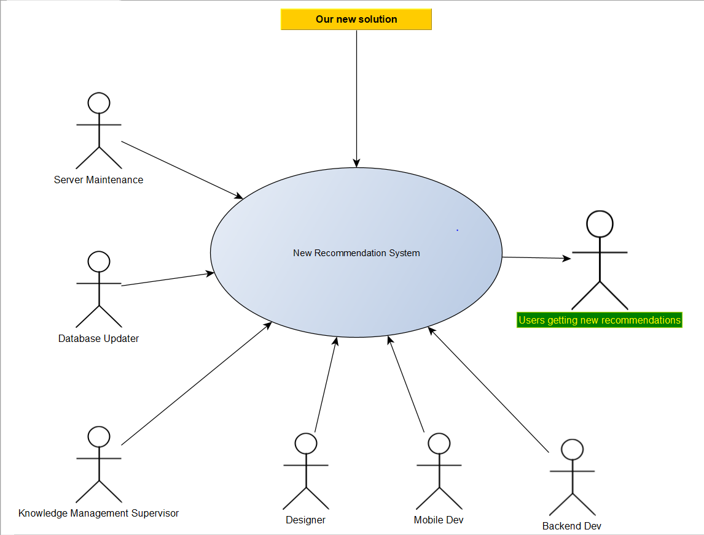

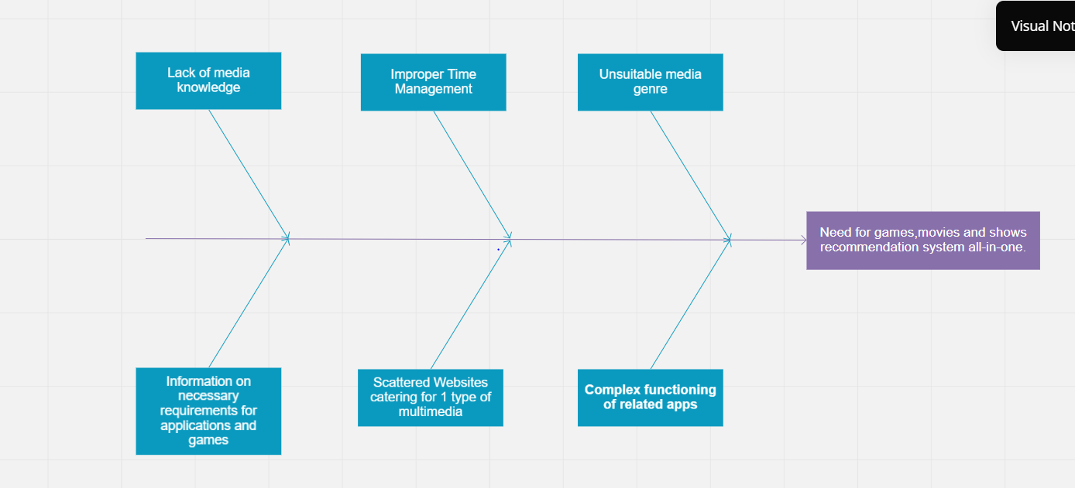

(Eshan Das)

(Aryaman Mishra)

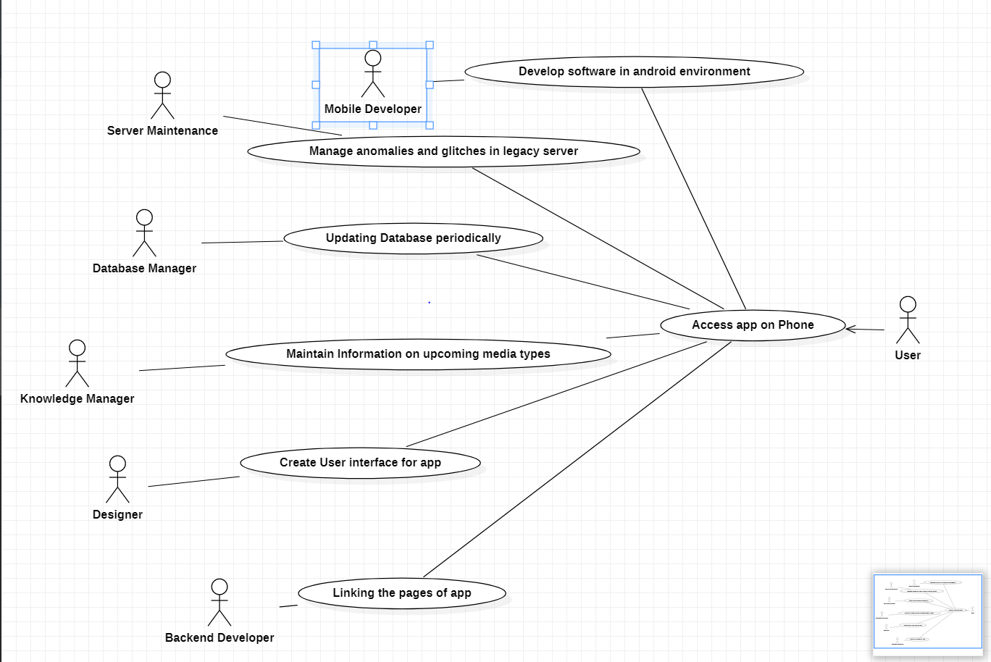

(Aryaman Mishra and Eshan Das)

BUSINESS ACTOR-Users(CUSTOMERS)

BUSINESS WORKERS-Mobile and Backend Developer,Server Maintenance,Database Manager,Knowledge Manager,Designer

BUSINESS USE CASES-Developing in Android IDE,Manage server,Updation of databases,Maintain intel on upcoming new multimedia types,create interactive UI and linking of app pages.

BUSINESS ENTITIES-ACTORS,WORKERS,USE CASES

Project Scheduling(Aryaman Mishra)

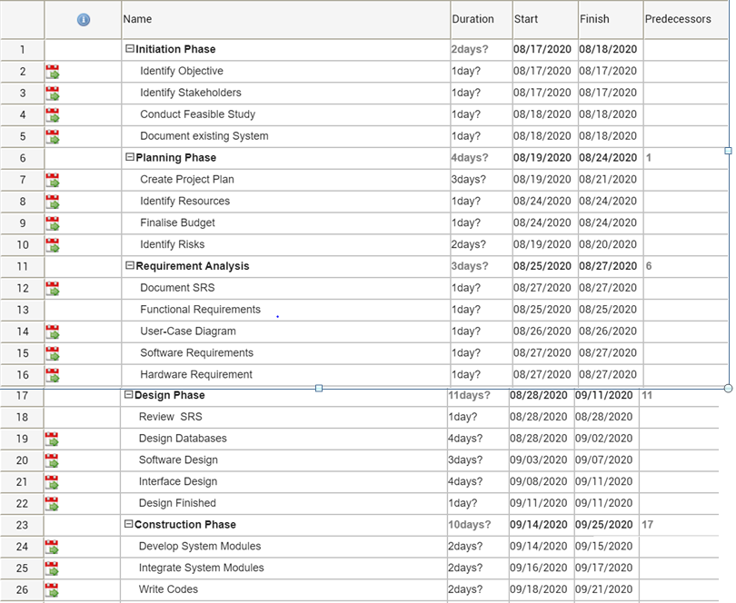

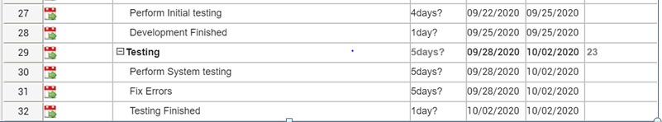

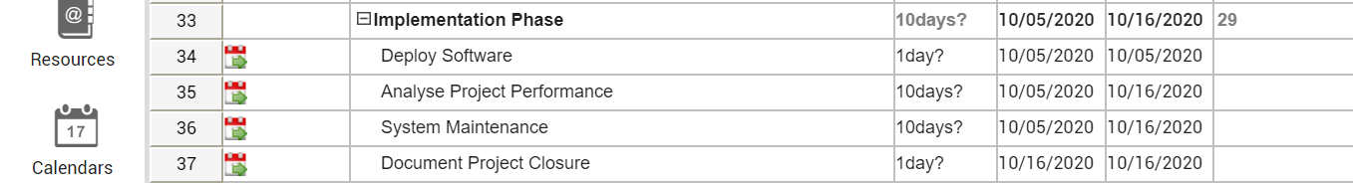

WBS with GANTT CHART(Aryaman Mishra)

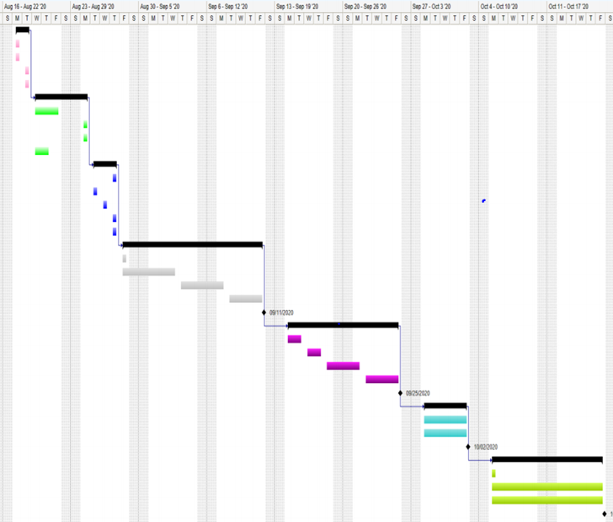

AMBUIGITIES:The client requires that enough number of people should be able to access the systems at the same time which varies from person to person.

INCONSISTENCIES:There are a variety of people on the server who have different tastes for watching movies,streaming TV shows and playing games.It becomes difficult as to waht recommendations must be provided to a given user.

INCOMPLETENESS:There must be information on other websites so that we can find out the trends and justify the recommendations for games,movies abd TV Shows given to the user.

(Aryaman Mishra and Eshan Das)

Work Break down structure by Product(Aryaman Mishra)

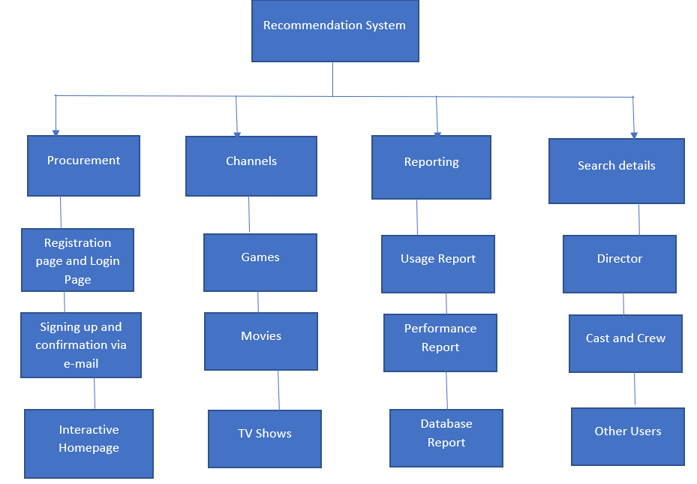

Work Break Down Structure by phase(Eshan Das)

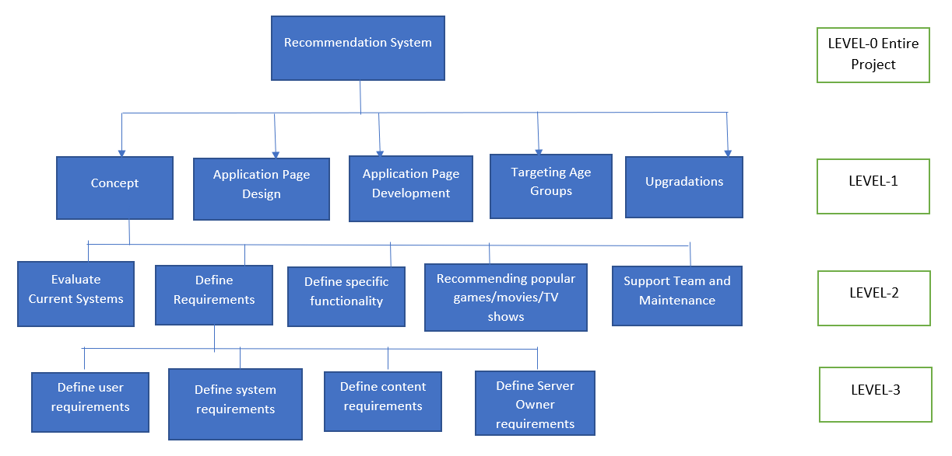

Data Flow Diagrams

LEVEL 0(ARYAMAN MISHRA)

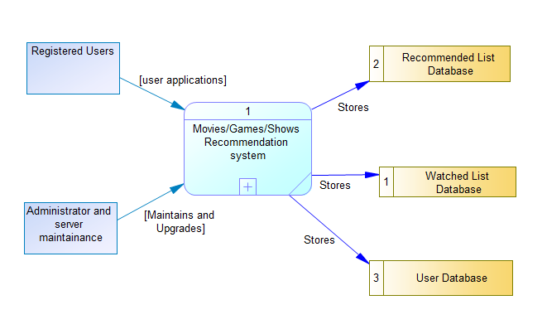

LEVEL 1 (ESHAN DAS)

